DBT Assignment 11
- Create a view that shows all of the customers who have the highest ratings.
- CREATE VIEW view1_sales AS SELECT * FROM customers WHERE rating = (SELECT MAX(rating) FROM customers);
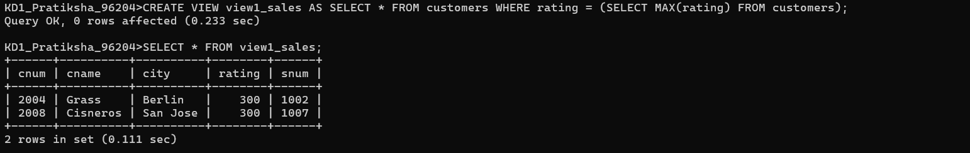

- Create a view that shows the number of salespeople in each city.
- CREATE VIEW view2_sales AS SELECT city, COUNT(sname) FROM salespeople GROUP BY city;
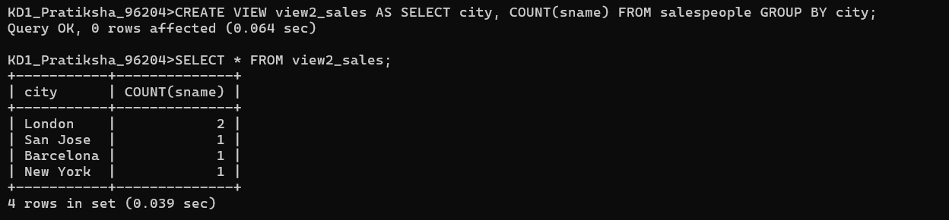
- Create a view that shows the average and total orders for each salesperson after his or her name. Assume all names are unique.
- CREATE VIEW view3_sales AS SELECT s.sname, AVG(amt), COUNT(onum) FROM orders o INNER JOIN salespeople s ON o.snum = s.snum GROUP BY s.snum, s.sname;
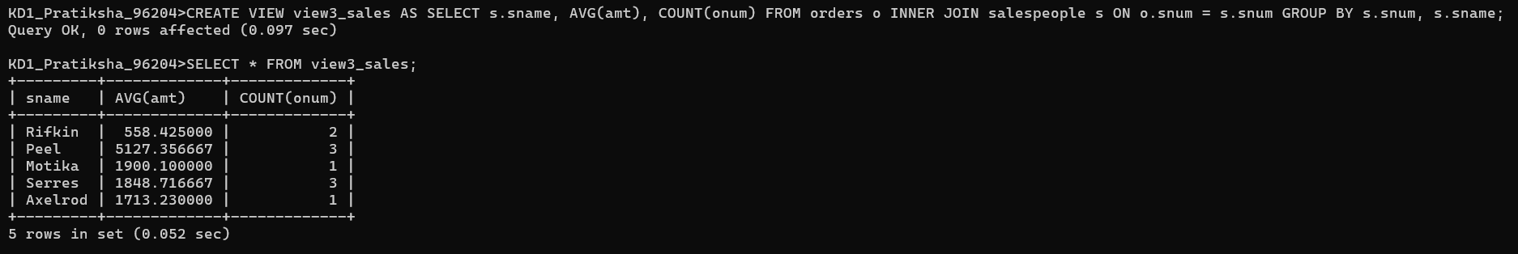
- Create a view that shows each salesperson with multiple customers.
- CREATE VIEW view4_sales AS SELECT COUNT(c.cname) cnt, s.snum, s.sname FROM salespeople s INNER JOIN customers c ON s.snum = c.snum GROUP BY s.snum, s.sname HAVING COUNT(c.cname) > 1;
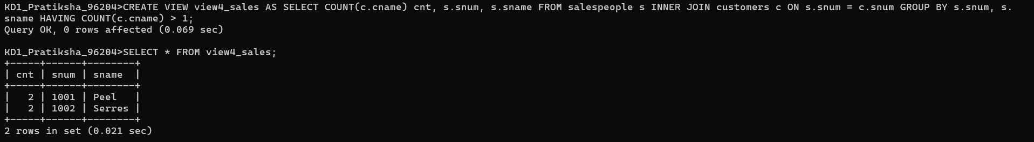
- Which of these views are updateable (will allow DML operations)?
#1 Create View Dailyorders as Select Distinct cnum, snum, onum, odate from Orders; -> NOT UPDATEABLE
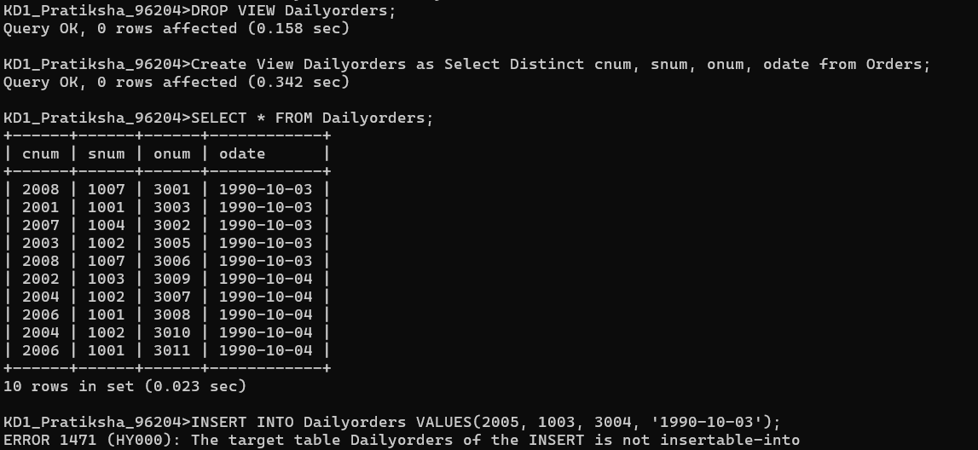

#2Create View Custotals as Select cname, Sum (amt) Sum_Amt from Orders, Customers where Orders.cnum=Customers.cnum Group by cname; -> NOT UPDATEABLE
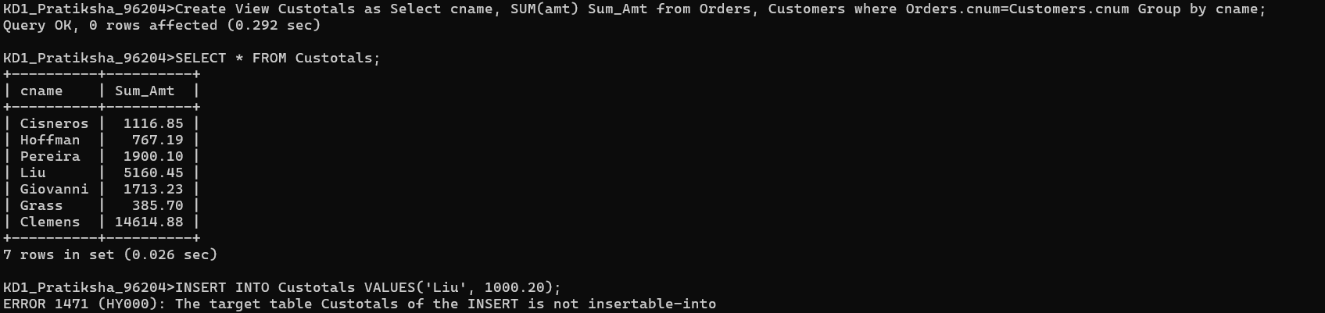

#3 Create view Thirdorders as Select * from Dailyorders where odate=’1990-10-03’; -> NOT UPDATEABLE
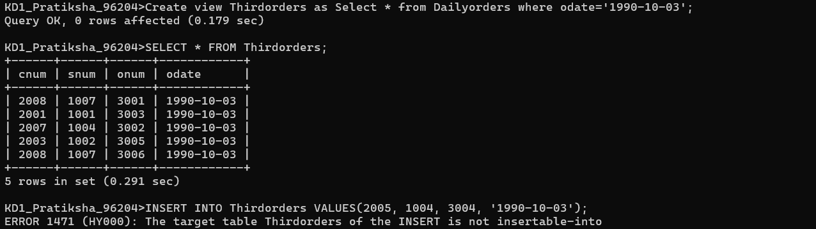

#4 Create view Nullcities as Select snum, sname, city from Salespeople where city is NULL OR sname BETWEEN ‘A’ and ‘MZ’; -> UPDATEABLE
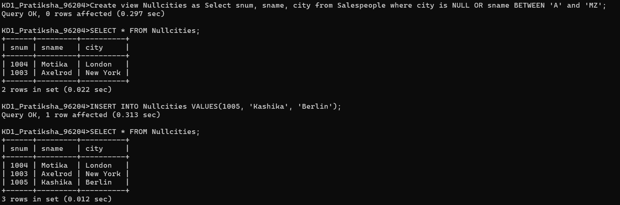

- Create a view of the Salespeople table called Commissions. This view will include only the snum and comm fields. Through this view, someone could enter or change commissions, but only to values between .10 and .20.
- CREATE VIEW view5_sales AS SELECT snum, comm FROM salespeople WHERE comm BETWEEN .10 AND .20 WITH CHECK OPTION;

